**DAY – 2/ 180 Introduction to C++**

**Introduction to FlowCharts.**

1. Two numbers are given find their product?

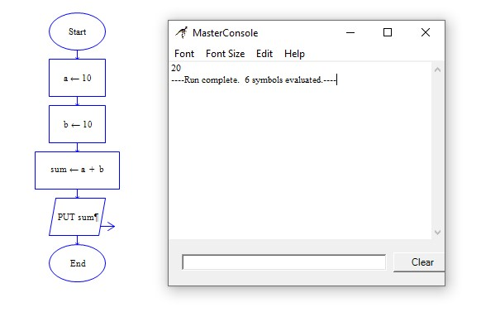

2. Two numbers are given a & b, find a divided by b?

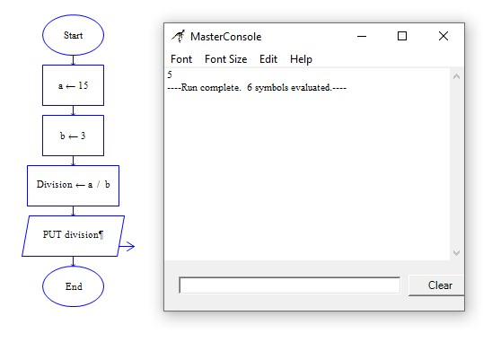

3. Find a square of a number?

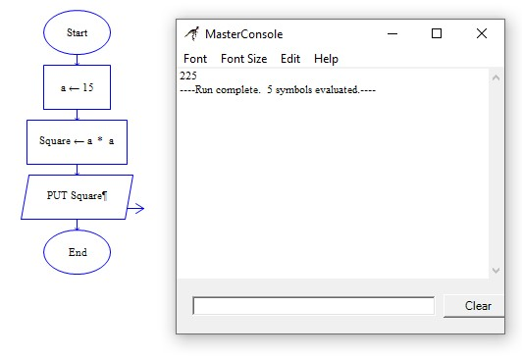

4. Two numbers a & b are given, find which one is greater or both equal?

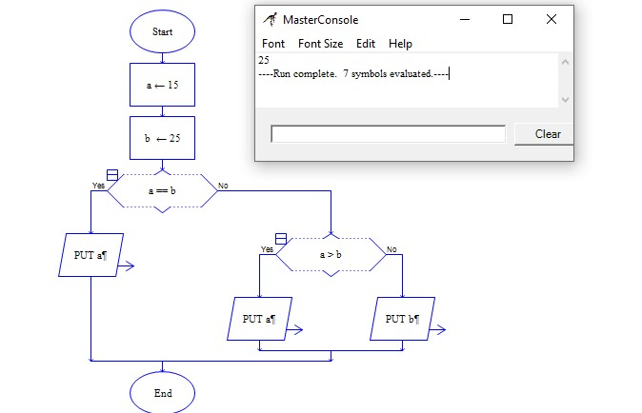

5. A number is given, find if it is +ve / -ve ?

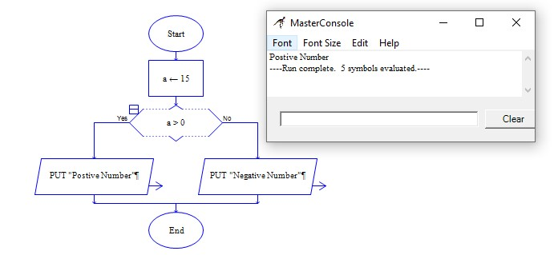

6. Find the factorial of a given number?

